

用款审批单(4 张)：



|  |  |  |  |  |  |  |
| --- | --- | --- | --- | --- | --- | --- |
|  | |  | |  | |  |
|  | | | | | | |
|  |  | | |  |  |  |
| 1 |  | | |  | |  |
| 2 |  | | |  | |  |
|  | | | |  | | |
|  | | | |  | | |
|  | | |  |  | | |
|  | | | |  | | |





|  |  |  |  |  |  |  |  |  |
| --- | --- | --- | --- | --- | --- | --- | --- | --- |
|  | |  | | |  | | |  |
|  | | | | | | | | |
|  |  | | | |  | | |  |
| **1** |  | | | |  | | |  |
| **2** |  | | | |  | | |  |
|  | | | | |  | | | |
|  | | | | |  | | | |
|  | | |  |  | |  |  | |
|  | | |  | | | |  | |





|  |  |  |  |  |  |  |  |
| --- | --- | --- | --- | --- | --- | --- | --- |
|  | |  | |  | | |  |
|  | | | | | | | |
|  |  | | |  | | |  |
| **1** |  | | |  | | |  |
| **2** |  | | |  | | |  |
|  | | | |  | | | |
|  | | | |  | | | |
|  | | |  |  |  |  | |
|  | | | |  | | | |
|  | | | |  | | | |





|  |  |  |  |  |  |  |  |  |
| --- | --- | --- | --- | --- | --- | --- | --- | --- |
|  | |  | | |  | | |  |
|  | | | | | | | | |
|  |  | | | |  | | |  |
| **1** |  | | | |  | | |  |
| **2** |  | | | |  | | |  |
|  | | | | |  | | | |
|  | | | | |  | | | |
|  | | |  |  | |  |  | |
|  | | |  | | | |  | |







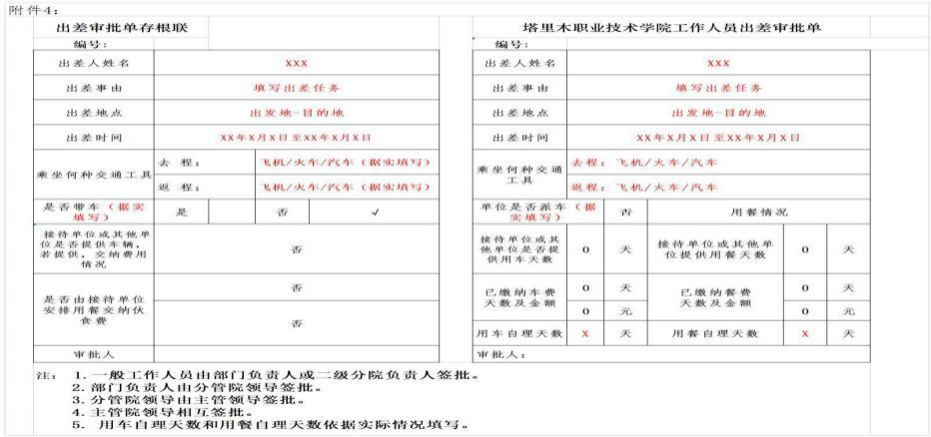







单位：塔里木职业技术学院**处室/**分院

单位：元

|  |  |  |  |  |  |  |  |  |
| --- | --- | --- | --- | --- | --- | --- | --- | --- |
|  |  |  |  |  |  |  |  |  |
| 1 | 例如：***赴乌市参加第八 届兵团高校辅导员素质大 赛差费 |  |  |  |  |  |  | 公务卡 |
|  |  |  |  |  | 储蓄卡 |
|  | 小计 |  |  |  |  |  |  |  |

处室 (二级分院) 领导：

制表人：





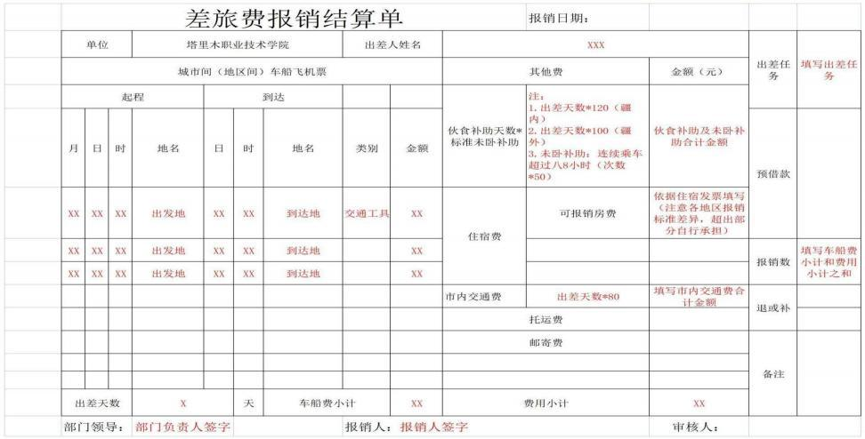





***年*月塔里木职业技术学院报销审批表

|  |  |  |  |  |  |  |  |  |  |  |  |  |  |  |  |  |  |
| --- | --- | --- | --- | --- | --- | --- | --- | --- | --- | --- | --- | --- | --- | --- | --- | --- | --- |
| 序 号 | 姓名 | 出差日 期 | 结束日 期 | 事由 | 公务员卡 | | | 公务卡报销金额明细 | | | | 公务卡以外报销金额明细 | | | | | 合计 |
| 日期 | 刷卡  金额 | 标准报 销金额 | 交通  费 | 住宿  费 | 培训 | 小计 | 交通费 | 住宿费 | 培训费 | 邮电费 | 小计 |
| 1 | *** | *月*日 | *月*日 | 1.*年*月* 日赴***参 加** (活 动) |  |  |  |  |  |  | 0 |  |  |  |  | 0 | 0 |
|  |  |  |  |  |  | 0 |  |  |  |  | 0 | 0 |
|  |  |  |  |  |  | 0 |  |  |  |  | 0 | 0 |
|  |  |  |  |  |  | 0 |  |  |  |  | 0 | 0 |
|  |  |  |  |  |  | 0 |  |  |  |  | 0 | 0 |
|  |  |  |  |  |  | 0 |  |  |  |  | 0 | 0 |
| 合计 | | |  |  |  | 0 | 0 | 0 | 0 | 0 | 0 | 0 | 0 | 0 | 0 | 0 | 0 |

处室 (二级分院) 领导：

制表人：

***年**月***学院外聘教师课时费发放表

单位：塔里木职业技术学院**学院

单位：元

|  |  |  |  |  |  |  |  |  |  |  |  |  |  |  |  |  |
| --- | --- | --- | --- | --- | --- | --- | --- | --- | --- | --- | --- | --- | --- | --- | --- | --- |
|  |  |  |  |  |  |  |  |  |  |  |  |  |  |  |  |  |
| 1 | 例如：支付经管学院 2023 年 11 月份外聘 教师课时费 |  |  |  |  |  |  |  |  |  |  |  |  |  |  |  |
| 2 |  |  |  |  |  |  |  |  |  |  |  |  |  |  |  |  |
|  | 小计 |  |  |  |  |  |  |  |  |  |  |  |  |  |  |  |

二级分院领导：

制表人：



单位：塔里木职业技术学院**处室/**分院

单位：元

|  |  |  |  |  |  |  |  |  |  |  |  |  |  |
| --- | --- | --- | --- | --- | --- | --- | --- | --- | --- | --- | --- | --- | --- |
|  |  |  |  |  |  |  |  |  |  |  |  |  |  |
| 1 | 例如：1.**年**月邀请** 单位**专家开展对***项 目的讲座 (评审) |  |  |  |  |  |  |  |  |  |  |  |  |
| 2 |  |  |  |  |  |  |  |  |  |  |  |  |  |
|  | 小计 |  |  |  |  |  |  |  |  |  |  |  |  |

二级分院(或处室)领导：

制表人：



单位：塔里木职业技术学院**处室/**学院

单位：元

|  |  |  |  |  |  |  |  |  |  |
| --- | --- | --- | --- | --- | --- | --- | --- | --- | --- |
|  |  |  |  |  |  |  |  |  |  |
| 1 | 例如：1.关于支付***项目 《****》论文版面费 |  |  |  |  |  |  |  |  |
| 2 |  |  |  |  |  |  |  |  |  |
|  | 小计 |  |  | 0.00 |  |  |  |  |  |

二级分院 (或处室) 领导：

制表人：

单位：塔里木职业技术学院



单位 ：元

|  |  |  |  |  |
| --- | --- | --- | --- | --- |
|  |  |  |  |  |
| 1 |  |  |  |  |
| 2 |  |  |  |  |
|  | 小计 |  | 0.00 |  |

党政办负责人：

制表人：